1.2.1 Experimental setup

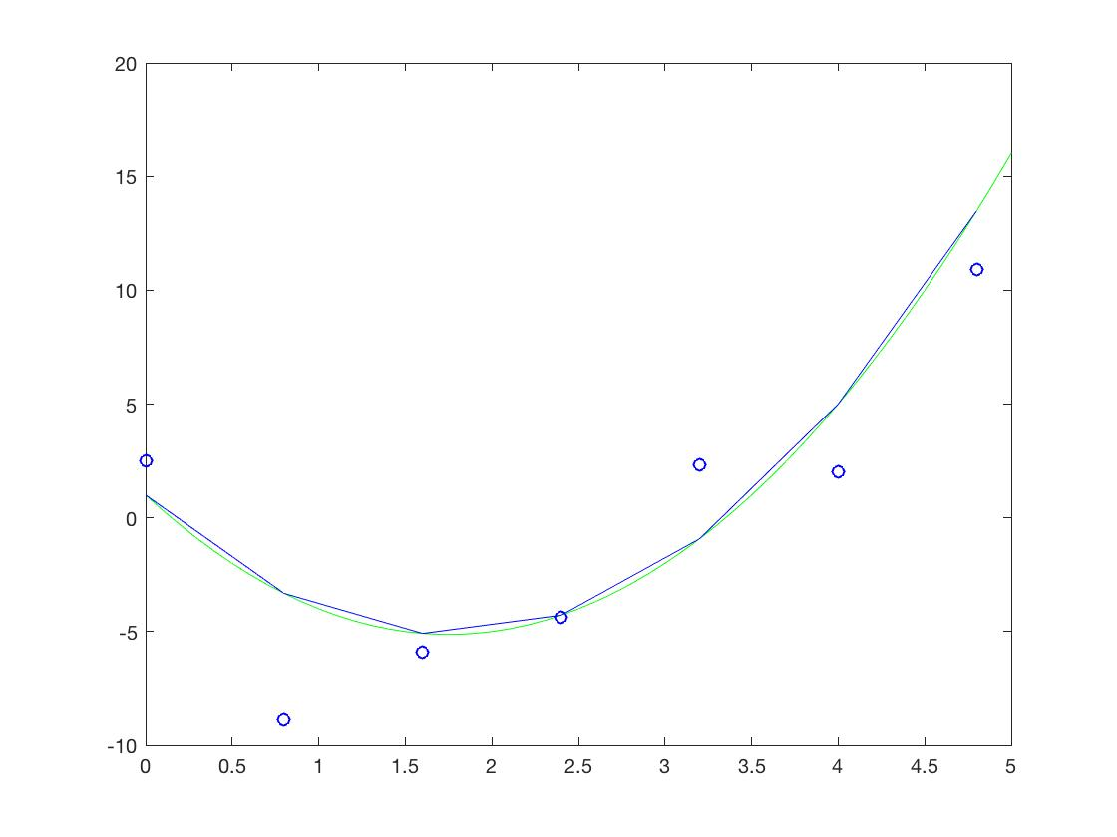

Figure : Experimental setup, vector of scalar input (green curve), training set (without feature transformation) with N=7 (blue dots) and prediction of the fitted model (blue curve).

1.2.2 Optimization: LMS-learning rule vs. closed form

What is the resulting weight vector when using the LMS-rule?

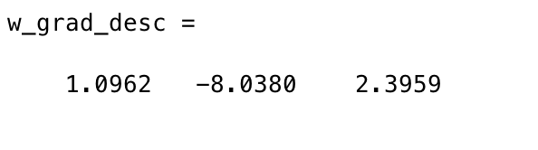

Figure : The resulting weighted vector by using LMS-rule

The resulting weight vector is display in figure 2.

How can you determine the optimal $w^{*}$ in closed form? Compare $w^{*}$ with the outcome of the LMS-rule training.

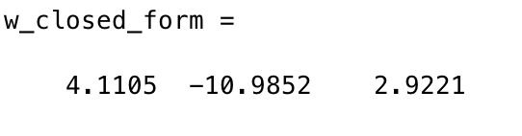

Figure : The resulting weight vector by using closed form

In compares with the outcome of LMS-rule function (error rate=30,80%), the of $w^{*}$ in closed form (error rate=24,09%), has a small error rate, which indicted a better performance.

1.2.3 Model-complexity and model-selection

Plot $mse$, $bias^{2}$  and $var$  against $d$  together in one plot. What is the relation of the quantities?

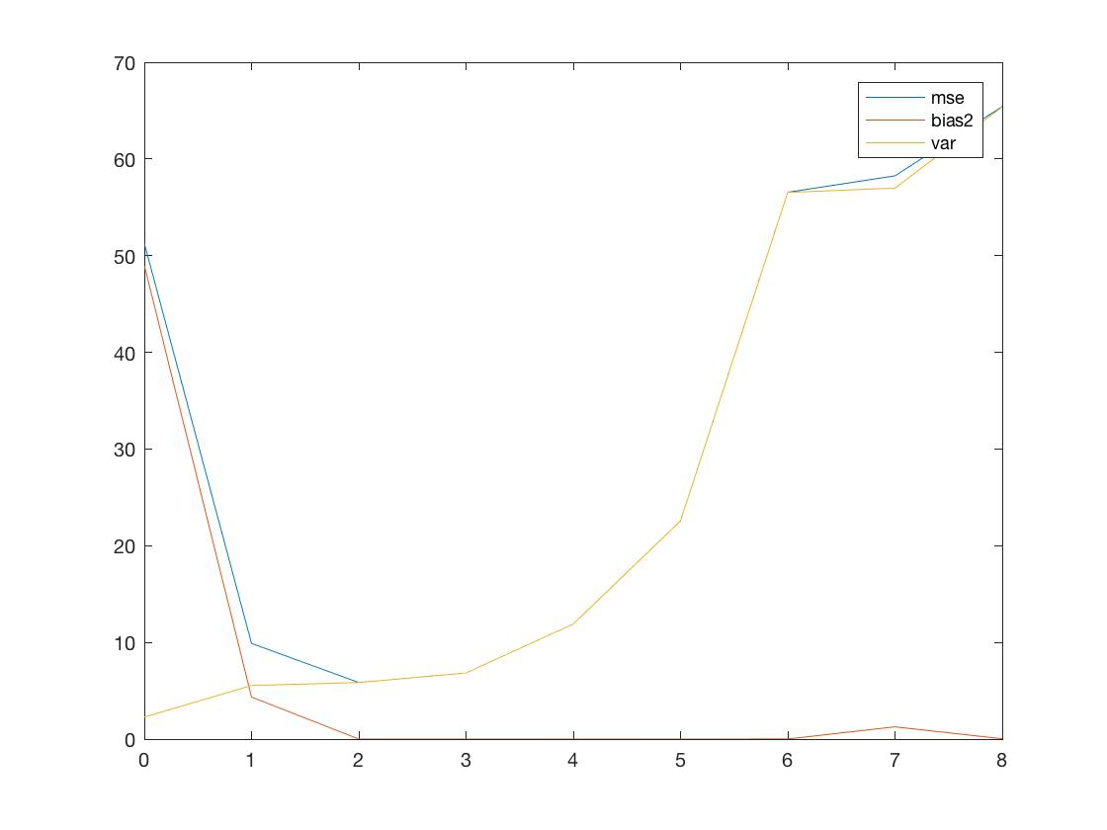

Figure : Plot of mean squared error (blue curve), bias2 (orange curve) and variance (yellow curve) against 1 till 8 dimensions.

The mean squared error is often used to assess the risk of an estimator, in the theory of point estimation. It is the average of the losses generated by the estimation errors when applying a model of estimator for a function.

If $\hat{θ}$ is an estimator of an unknown parameter $θ$, then the mean squared error can be define as:

$$MSE\left(\hat{θ}\right)= E_{\hat{θ}}[{(\hat{θ}-θ)}^{2}]$$

which can also be written as:

$$MSE\left(\hat{θ}\right)= {Var}_{\hat{θ}}\left(\hat{θ}\right)+Bias[{(\hat{θ},θ)}^{2}]$$

The MSE is the sum of the variance of the estimator and squared bias of this estimator. This can be proven by the plot figure 4.